**IBM-Project-10570-1659188481**

**Plasma Donor Application**

* Team Leader : Athithyan
* Team member : Ravendhar
* Team member : Sujeeth
* Team member : Lokeshwara

**Status** :

* Ideation Phase - done
* Problem Statement - done
* Project Design & Planning (1) - done
* Project Design & Planning (2) - done
* Project planning - done
* Sprint 1 - done
* Sprint 2 - done
* Sprint 3 - done
* Sprint 4 - done

**Project completed:**

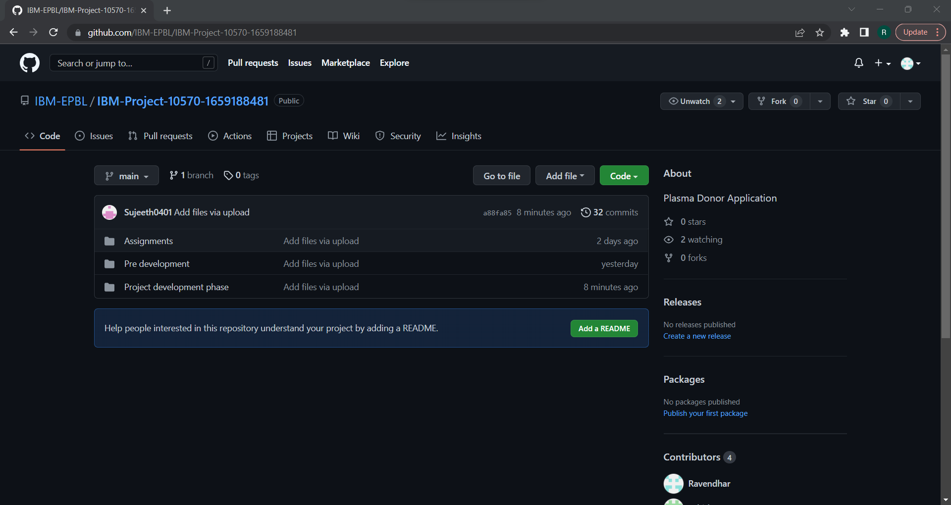Github ﬁles:

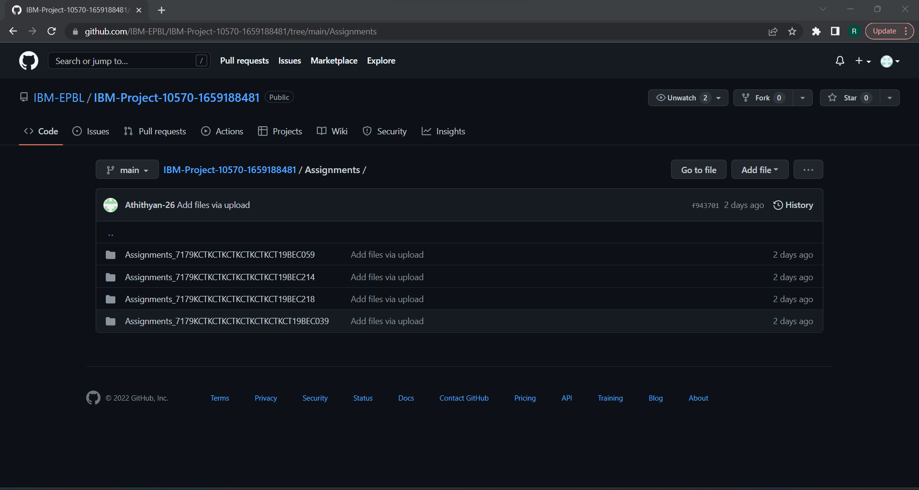

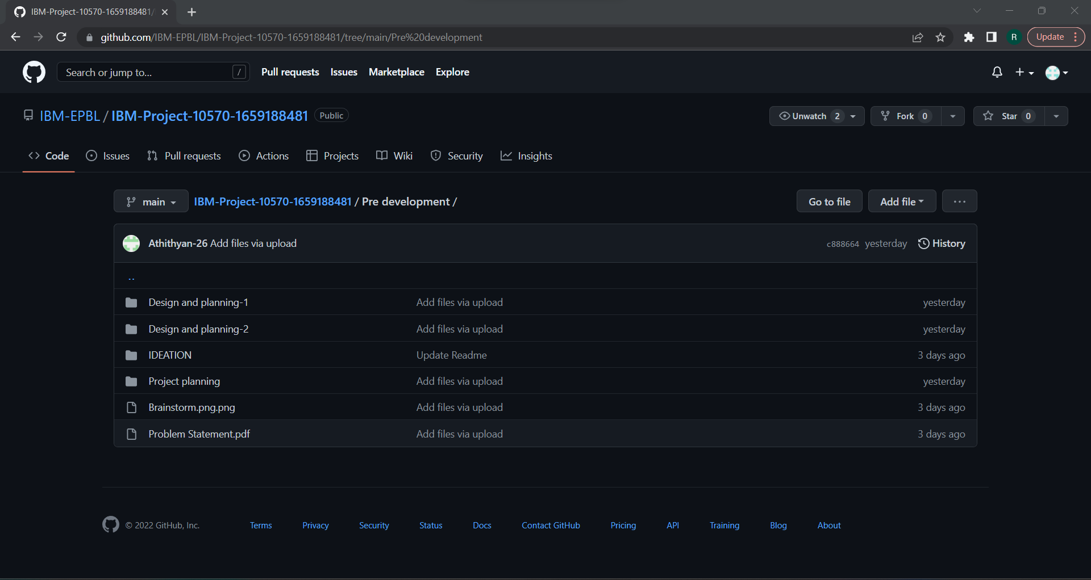

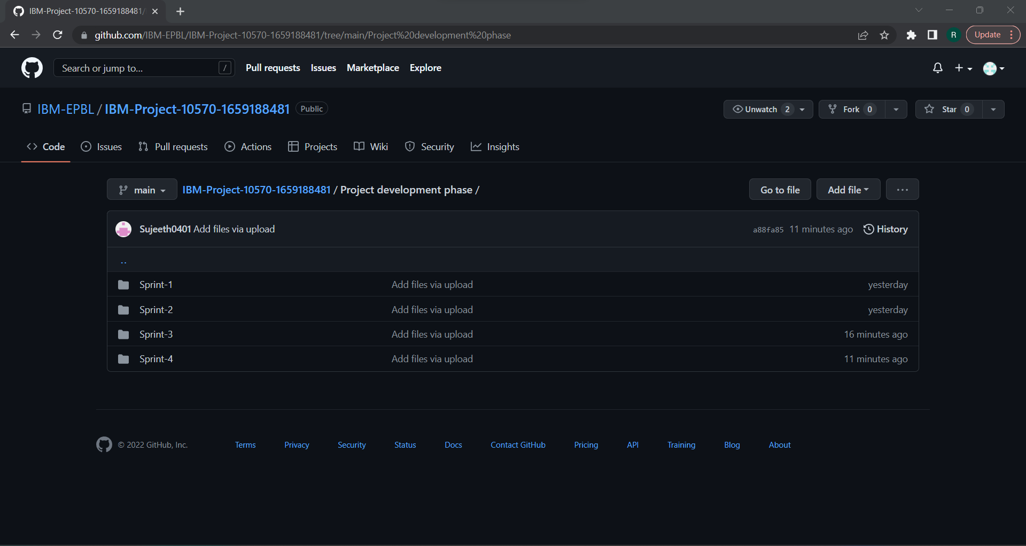

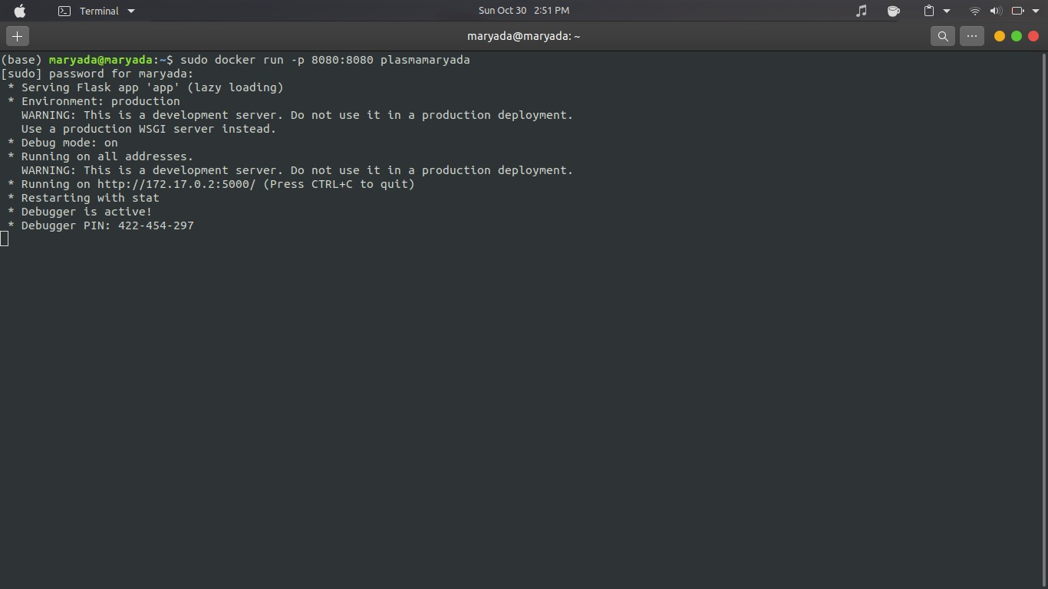

**[SETTING UP APPLICATION ENVIRONMENT](https://careereducation.smartinternz.com/Student/guided_project_workspace/40734#collapse1) [IMPLEMENTING WEB APPLICATION](https://careereducation.smartinternz.com/Student/guided_project_workspace/40734#collapse2) [INTEGRATING SENDGRID SERVICE](https://careereducation.smartinternz.com/Student/guided_project_workspace/40734#collapse3)**

**[DEPLOYMENT OF APP IN IBM CLOUD](https://careereducation.smartinternz.com/Student/guided_project_workspace/40734#collapse4)**

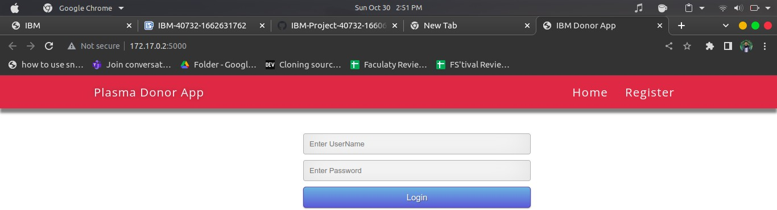

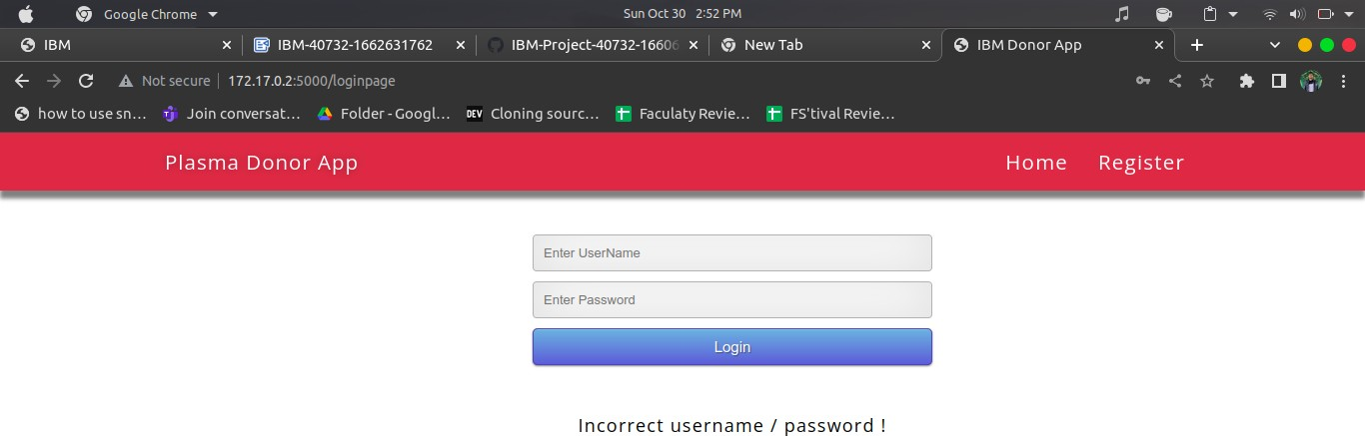

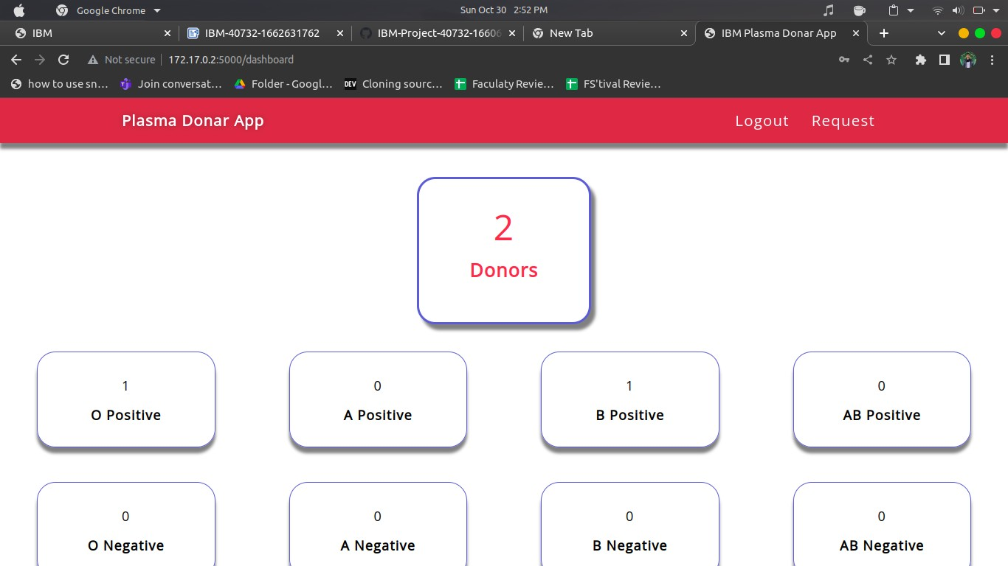

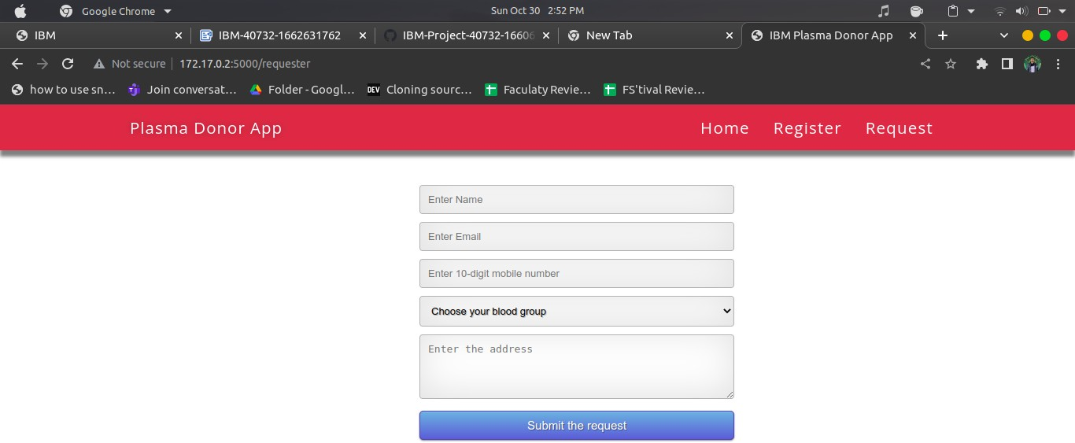

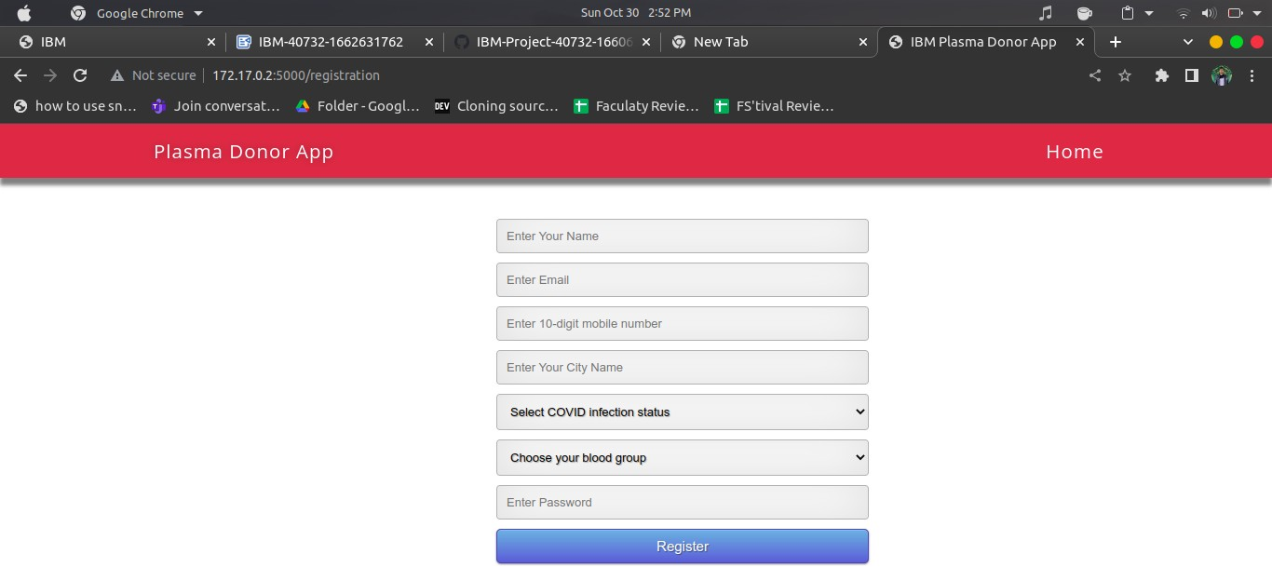

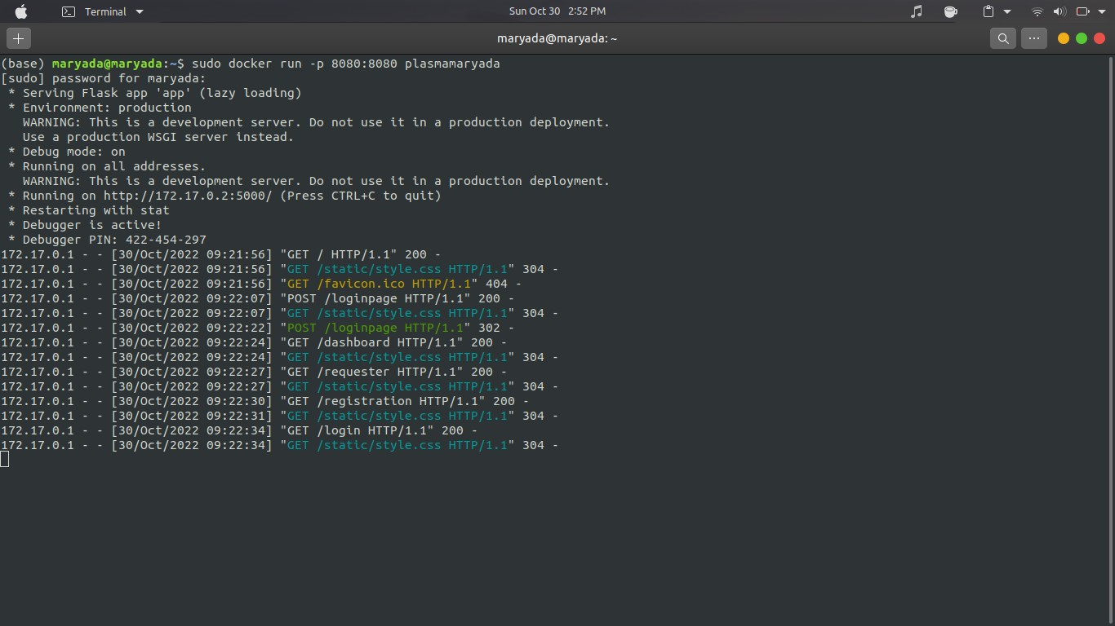

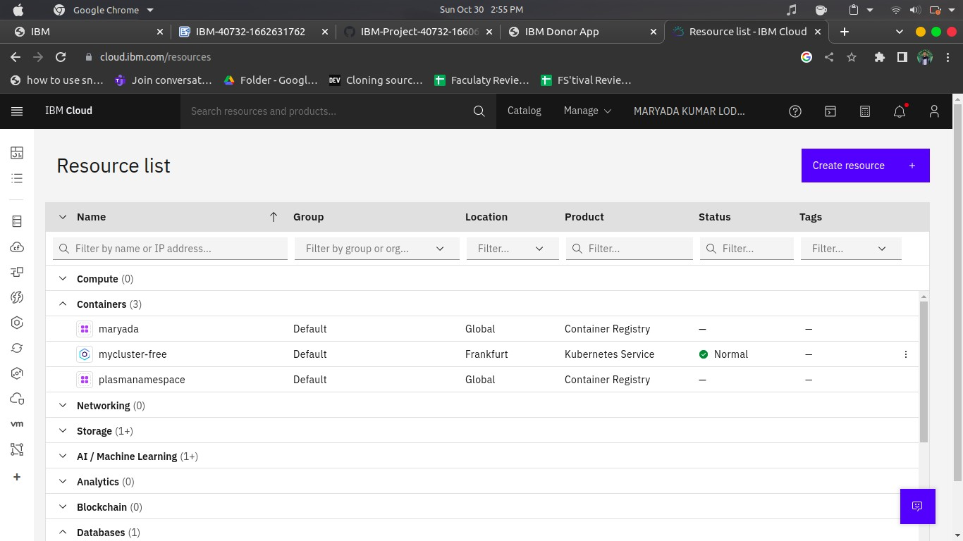

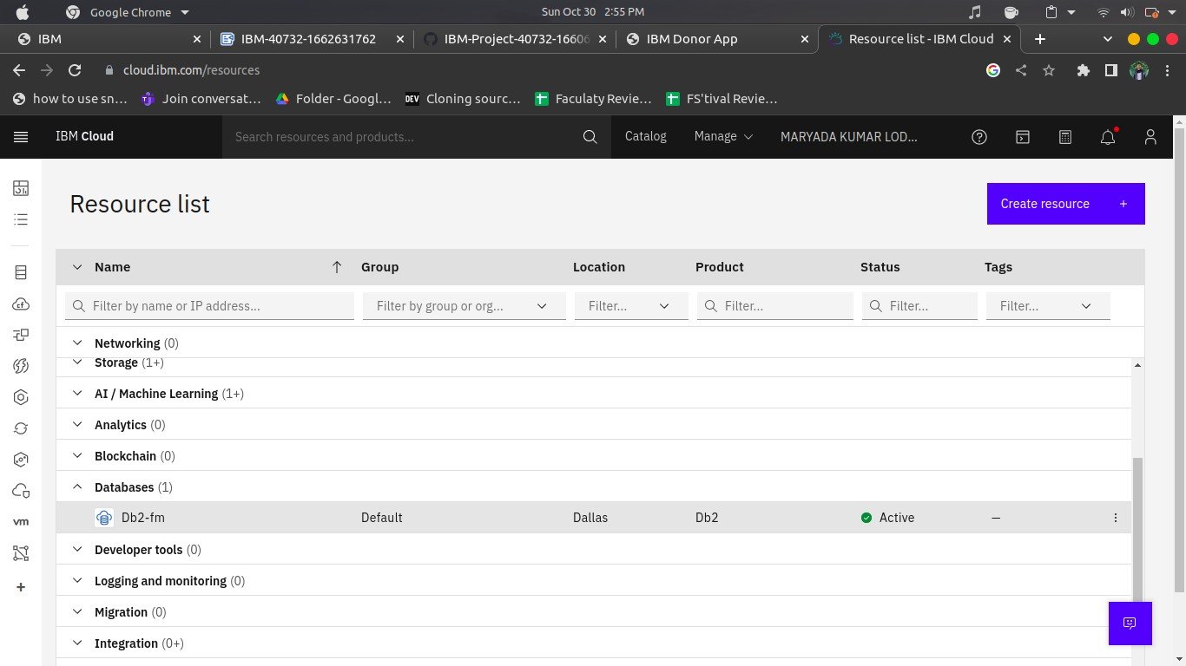

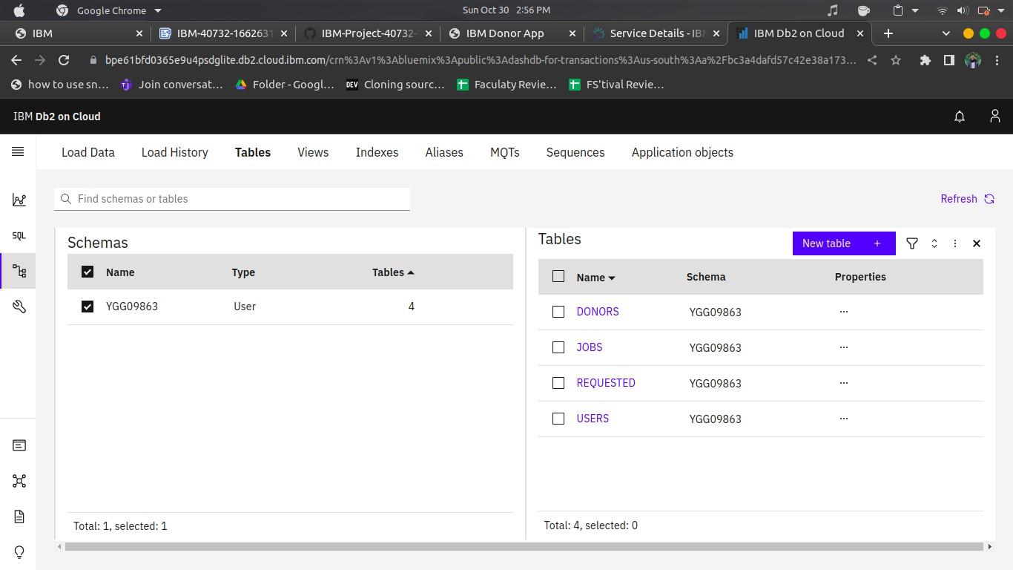

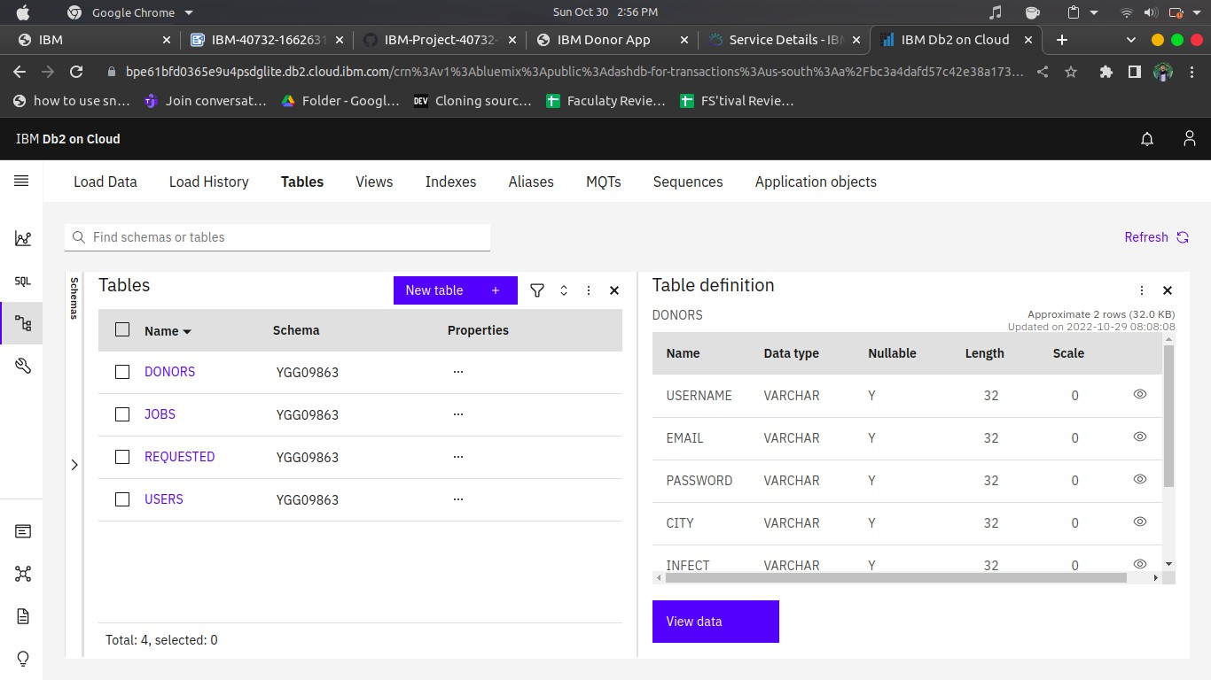

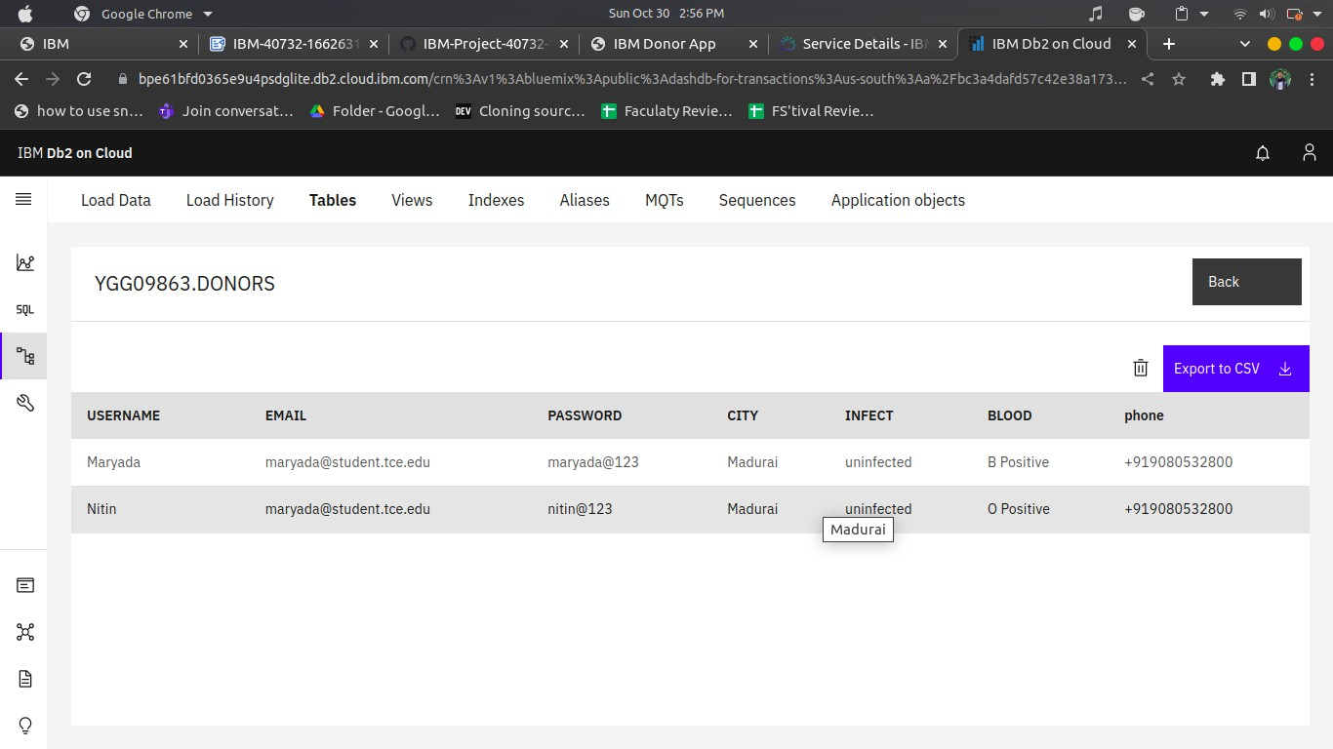

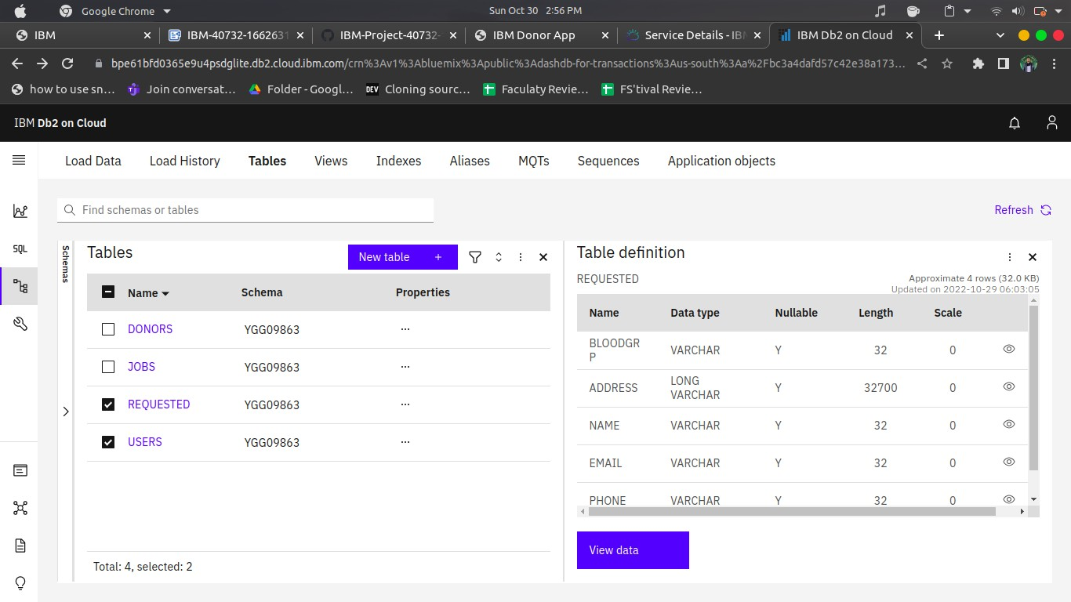

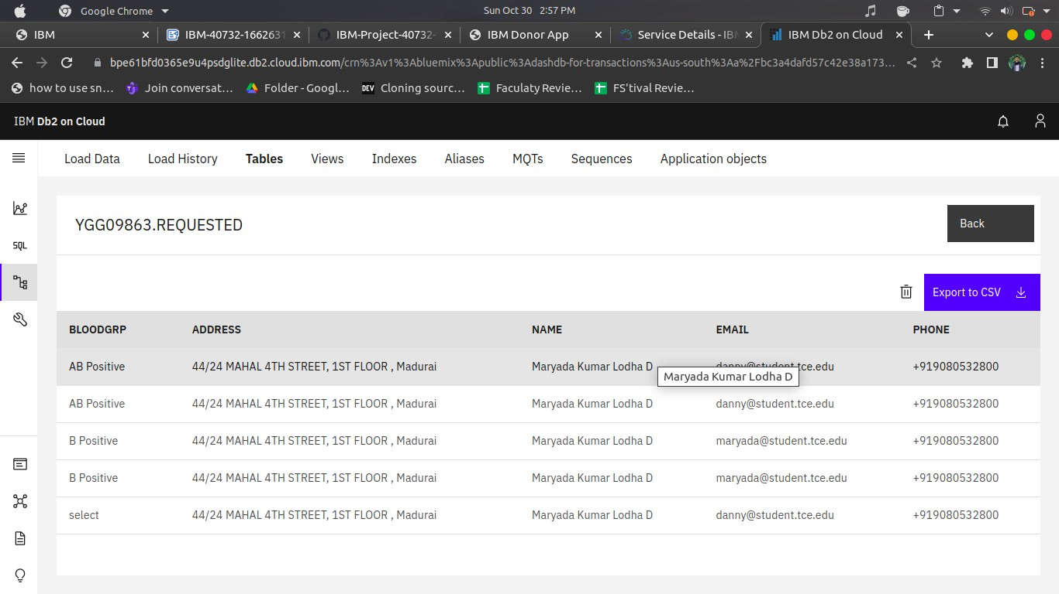

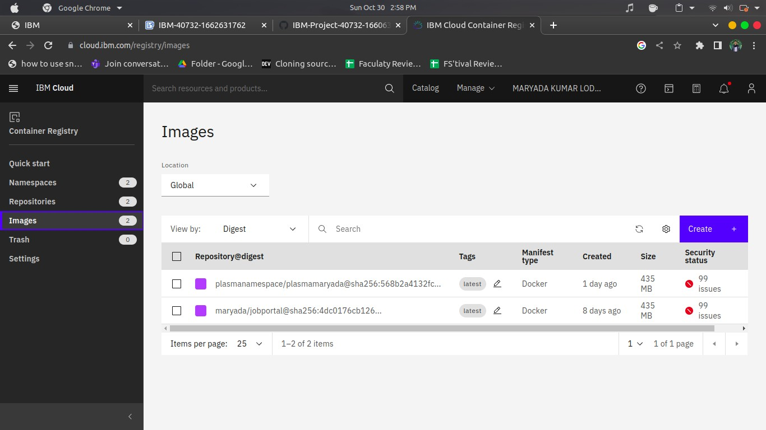

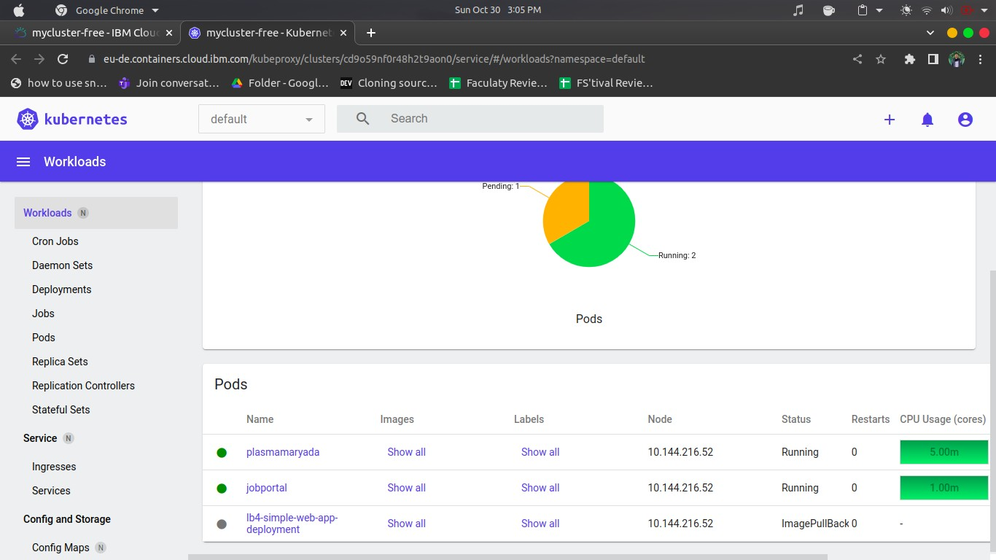

Source code: [Git link](https://github.com/IBM-EPBL/IBM-Project-40732-1660633417/tree/main/Final%20deliverable/Plasma%20donor%20app%20code)